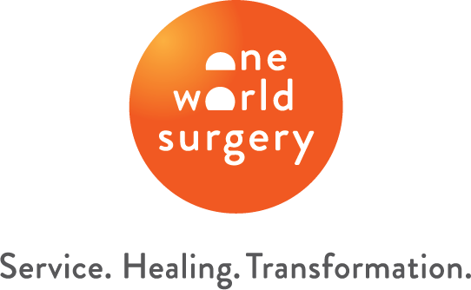

Dates:

Location: Honduras

Specialties:

One World Surgery is a global health nonprofit with a mission to ignite the spirit of service and transform lives by providing access to high-quality surgical and primary care.

One World Surgery funds and operates a surgery center in Honduras on the 2,000 acre property of their partner Nuestros Pequeños Hermanos, a home for abandoned and disadvantaged children.

During weeklong medical missions, volunteers come together with One World Surgery’s local team to provide life-changing surgical and primary care for patients.

Now Recruiting the Following Roles
- [role]
- [role]
- [role]
- [role]

Cost
Program Fees
- $1000 for 1st participant (regardless of age)
- $500 for additional family member 18 years and older
- $250 for additional family member under 18 years

Program fees cover food and accommodations, ground transportation
in the mission country, and emergency medical and evacuation
insurance for a 1-week medical mission.

Volunteers are also responsible for airfare and any other travel-related
costs.

For inquiries, contact medicalmissions@oneworldsurgery.org.

For more information and to apply, please visit https://oneworldsurgery.org/medical-mission/.

